Project Design Phase-II
Data Flow Diagram & User Stories
Date | 21 October 2026
Team ID
Project Name | Incident Lifecycle Automation in ServiceNow
Maximum Marks | 4 Marks

Data Flow Diagrams:
A Data Flow Diagram (DFD) is a visual representation of how information moves through a system. It shows who or what sends data into the system, which processes change that data, where the data is stored and what is sent back out. For this project, the DFD shows how an incident moves through ServiceNow from the moment it is reported until it is closed.
Example: (Simplified)
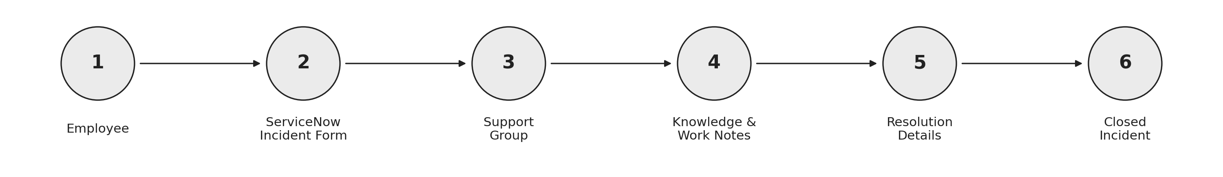
- The employee reports an IT issue and the service desk agent records it in ServiceNow.
- The agent selects the category, urgency, service and configuration item, and assigns the incident to a support group.
- The support group investigates the incident using knowledge articles, related incidents and work notes.
- A change request is linked if a change is needed to fix the issue.
- The cause, workaround and resolution notes are recorded and SLA status is tracked.
- The incident is closed and the employee is notified.

DFD Components:
External entities | Employee (Caller), Service Desk Agent, Resolver Support Group and Service Desk Manager
Processes | 1 Record & Classify Incident, 2 Assign Incident, 3 Investigate Incident, 4 Resolve & Close Incident, 5 Track SLA
Data stores | D1 Incident Records, D2 Knowledge Base, D3 Change Requests, D4 SLA Records
DFD Level 0: Incident Lifecycle Automation in ServiceNow
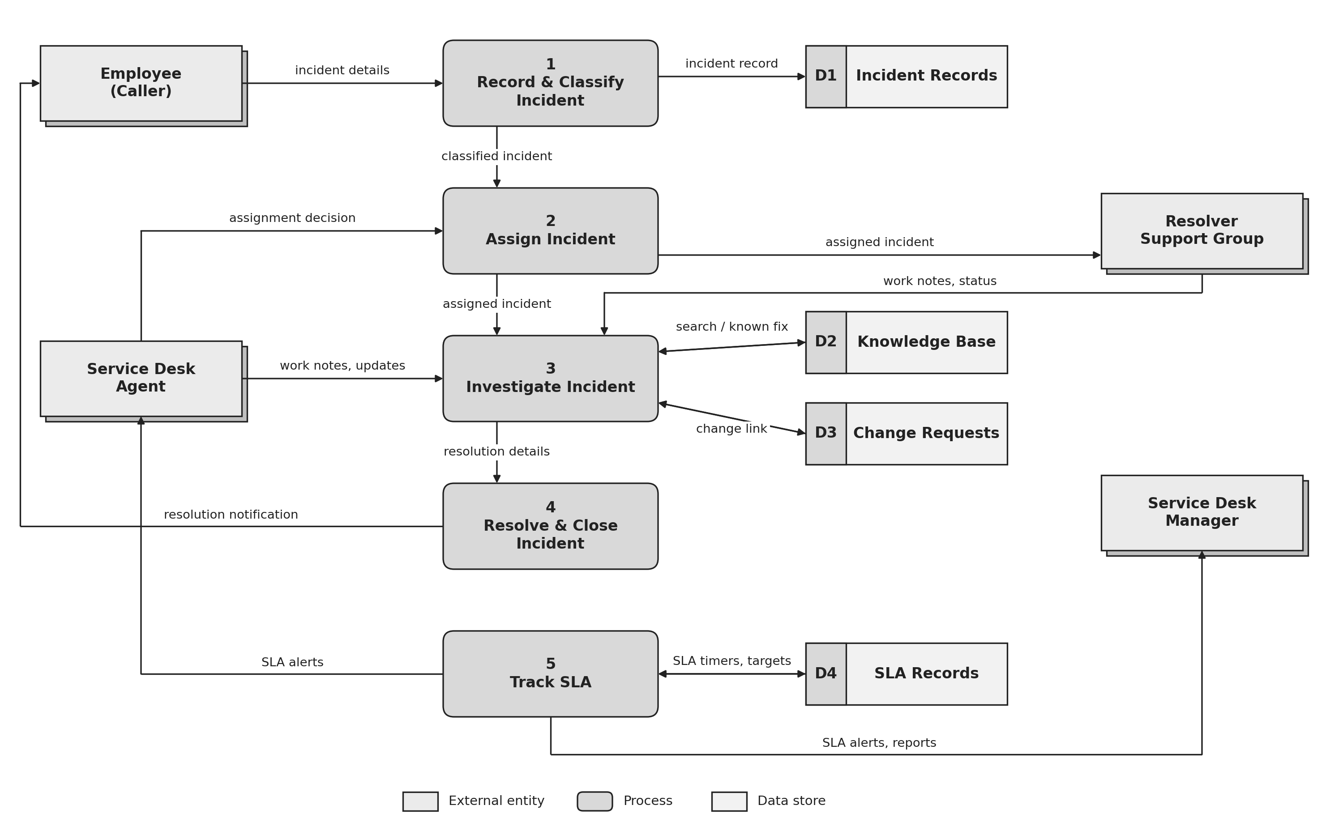
User Stories
The table below lists the user stories for the incident lifecycle, grouped by user type and functional requirement (epic).
User Type | Functional Requirement (Epic) | User Story Number | User Story / Task | Acceptance criteria | Priority | Release
Employee (Caller) | Incident Recording | USN-1 | As an employee, I can report an IT issue by describing the problem and my contact details. | The incident is created and I receive an incident number. | High | Sprint-1
Employee (Caller) | Incident Recording | USN-2 | As an employee, I receive a confirmation once my incident is recorded. | I receive a notification with the incident number and short description. | Medium | Sprint-1
Employee (Caller) | Incident Tracking | USN-3 | As an employee, I can check the status of my incident. | I can see the current state and the assigned support group. | Medium | Sprint-2
Employee (Caller) | Incident Tracking | USN-4 | As an employee, I am notified when my incident is resolved. | I receive a message with the resolution summary. | High | Sprint-2
Service Desk Agent | Classification | USN-5 | As an agent, I can set the category, subcategory, urgency, service and configuration item on an incident. | The incident saves with all classification fields filled in and visible. | High | Sprint-1
Service Desk Agent | Classification | USN-6 | As an agent, I can set the impact and urgency so that the priority is calculated. | The priority updates according to the selected impact and urgency. | High | Sprint-1
Service Desk Agent | Assignment | USN-7 | As an agent, I can assign an incident to the correct support group. | The incident shows the assignment group and appears in that group’s queue. | High | Sprint-1
Service Desk Agent | Assignment | USN-8 | As an agent, I can reassign an incident when it was routed to the wrong group. | The reassignment is saved with a note and the new group can see the incident. | Medium | Sprint-2
Service Desk Agent | Investigation | USN-9 | As an agent, I can search knowledge articles from the incident. | Matching articles are listed and I can attach one to the incident. | Medium | Sprint-2
Service Desk Agent | Investigation | USN-10 | As an agent, I can add work notes to record the troubleshooting steps. | Notes are saved with the time and author and shown in the activity history. | High | Sprint-1
Service Desk Agent | Investigation | USN-11 | As an agent, I can link related incidents to a parent incident. | Child incidents show the parent and the parent shows its child incidents. | Medium | Sprint-2
Support Group Member | Resolution | USN-12 | As a support group member, I can see the incidents assigned to my group. | The group queue lists the incidents with their priority and state. | High | Sprint-1
Support Group Member | Resolution | USN-13 | As a support group member, I can update the state and add work notes while investigating. | The state and notes are saved and visible to the agent. | High | Sprint-2
Support Group Member | Resolution | USN-14 | As a support group member, I can record the cause, workaround and resolution notes before resolving. | The incident cannot be resolved until the resolution details are entered. | High | Sprint-2
Support Group Member | Change Handling | USN-15 | As a support group member, I can create or link a change request when a change is needed to fix the incident. | The change request appears in the related records of the incident. | Medium | Sprint-3
Service Desk Manager | SLA Monitoring | USN-16 | As a manager, I can view the SLA status of open incidents. | SLA progress and breach status are shown for each incident. | High | Sprint-2
Service Desk Manager | SLA Monitoring | USN-17 | As a manager, I am alerted when an SLA is close to breaching. | An alert is sent when the SLA passes its warning point. | Medium | Sprint-3
Service Desk Manager | Reporting | USN-18 | As a manager, I can view reports of incidents by category, priority and state. | The report shows incident counts and can be filtered. | Low | Sprint-3
Administrator | Configuration | USN-19 | As an administrator, I can configure categories, assignment groups and SLA definitions. | The changes are saved and applied to new incidents. | High | Sprint-1
Administrator | Configuration | USN-20 | As an administrator, I can manage user roles and access. | Users only see the features allowed by their role. | Medium | Sprint-1

Priority and Release Notes:
High priority stories are needed for the core incident lifecycle (recording, classification, assignment, investigation and resolution). Medium priority stories improve efficiency and visibility. Low priority stories add reporting and can follow later.
Sprint-1 covers the core lifecycle and configuration, Sprint-2 adds tracking, reuse of knowledge and related incidents, and Sprint-3 adds change handling, SLA alerts and reports.

